Learning Goal: you will predict conditions needed to produce resonance in air columns and test predictions through inquiry
Set up your equipment as shown by your teacher. Select a tuning fork (1024 Hz & 2048 Hz). Sound the tuning fork and hold it over the end of the CLOSED air column. Raise the air column above the water level until you reach a resonance length. Record the length in the chart below. Then continue to raise the air column until the next resonance length is found. Record.
Note: the measuring scale on the plastic pipes is NOT in cm. The scale is 40 units = 30 cm. You will need to convert your
measured values from ‘units’ into cm. Example: convert ‘20 units’→ cm; 20 units x 30 cm/40 units = 15 cm
Data Analysis (refer to Figure 3, p289 in your text) c) Draw the 3rd resonant length
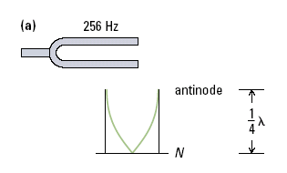
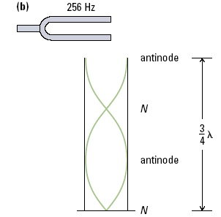
1st resonant length in an air column
2nd resonant length in an air column
3rd resonant length in an air column

1. As you held the tuning fork above the air column and raised the column up, you changed the length of the air column. At a certain height you heard a continuous loud antinode at the mouth of the column, indicating a standing wave pattern inside the column. Since the tuning fork is a single frequency, why do standing wave patterns occur only at certain column lengths?

2. For 2048 Hz tuning fork [resonance length 1 = ______ cm, resonance length 2 = ______ cm]
How far apart (in cm) are the adjacent ‘resonant lengths’? How much of a wavelength is this distance?
What is one wavelength, based on this distance?

Use these these results to determine the speed of sound in air, using:
v_{sound in air column} = f_{tuning fork}.λ_{standing wave in air colomn}

3. For 1024 Hz tuning fork: [resonance length 1 = ______ cm, resonance length 2 = ______ cm]
How far apart (in cm) are the resonant lengths? How much of a wavelength is this distance?
What is one wavelength, based on this distance?

Use the average of these results to determine the speed of sound in air, using:
v_{sound in air column} = f_{tuning fork}.λ_{standing wave in air colomn}

Ideal Speed of sound v_{sound}= _{332 m/s + 0.59T_[T= ______}ºC] _= _______ m/s__
What is the % accuracy for your experimental results compared to the ideal? 1024 Hz = ___ % 2048 = ____ %

